1. Bot will enter URL ishare.cardiff.gov.uk

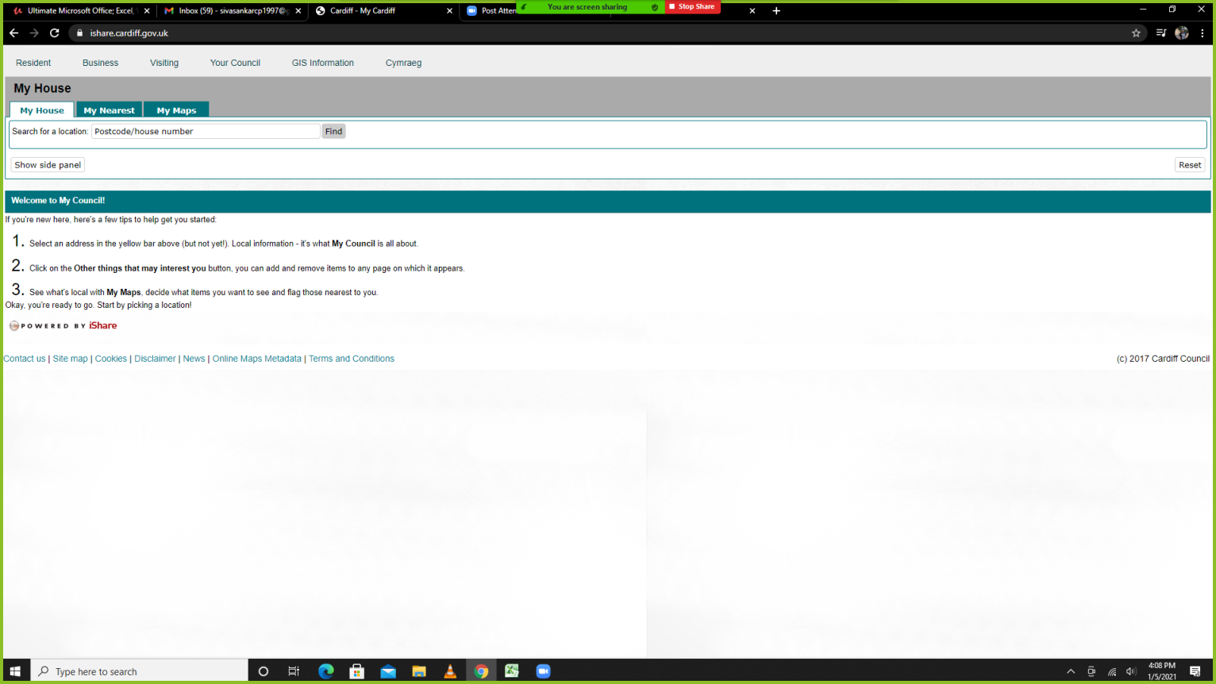

1. Bot will enter the PostalCode
   1. Bot will click **Find**
   2. Bot will select the property address

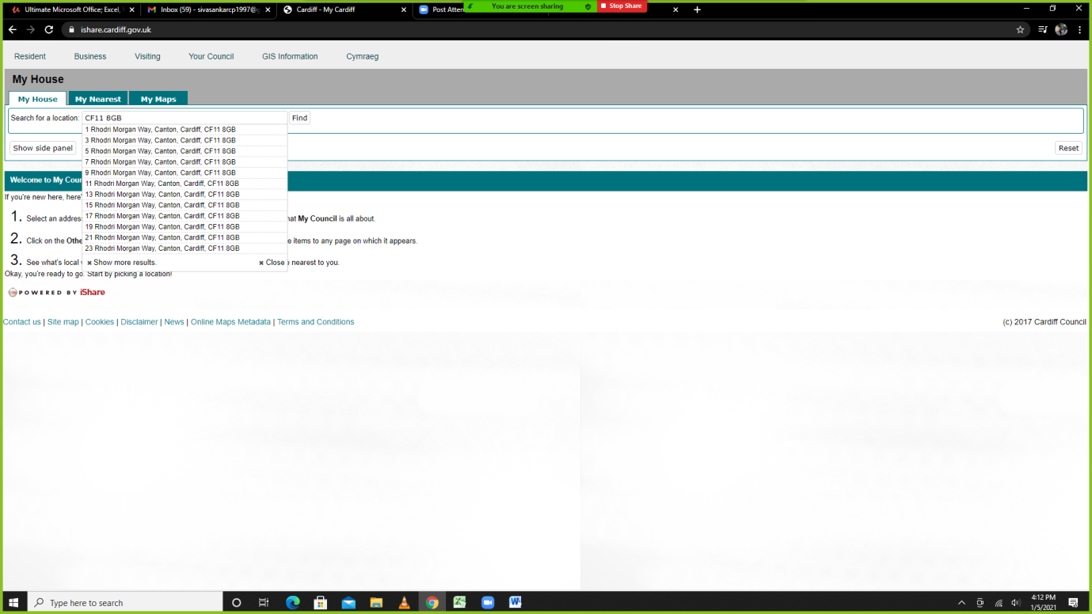

1. Bot will Click MY MAPS
   1. Bot will tick Environment
   2. Bot will tick Planning

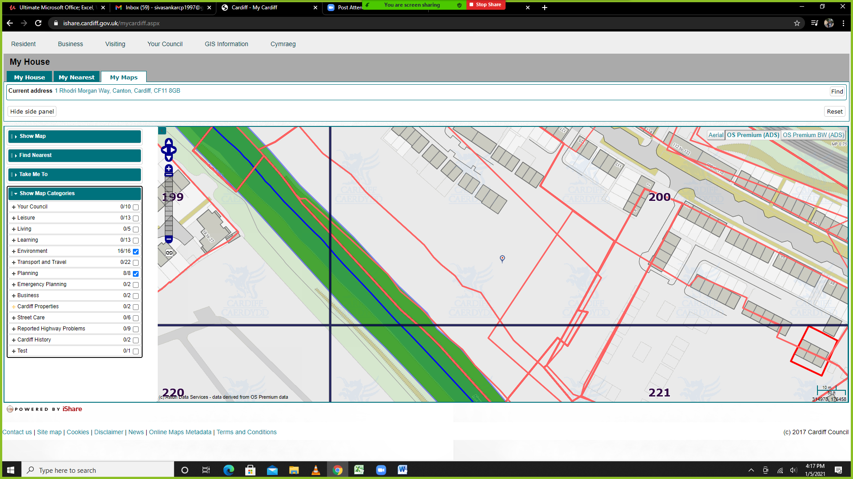

1. Bot will click on the Map (Drawing)

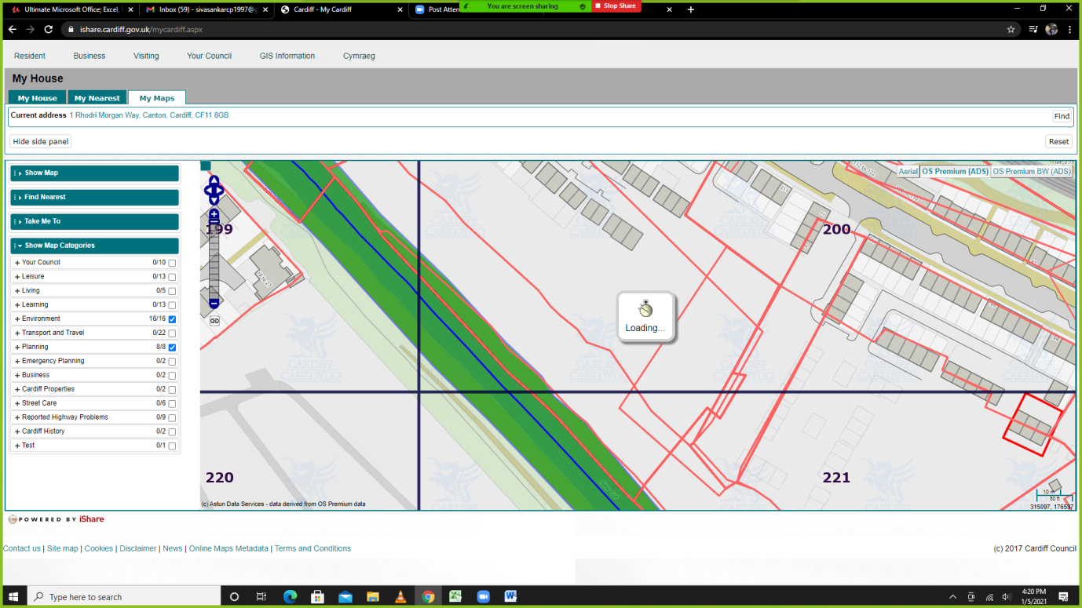

1. Bot will copy the Planning Extract for all Years

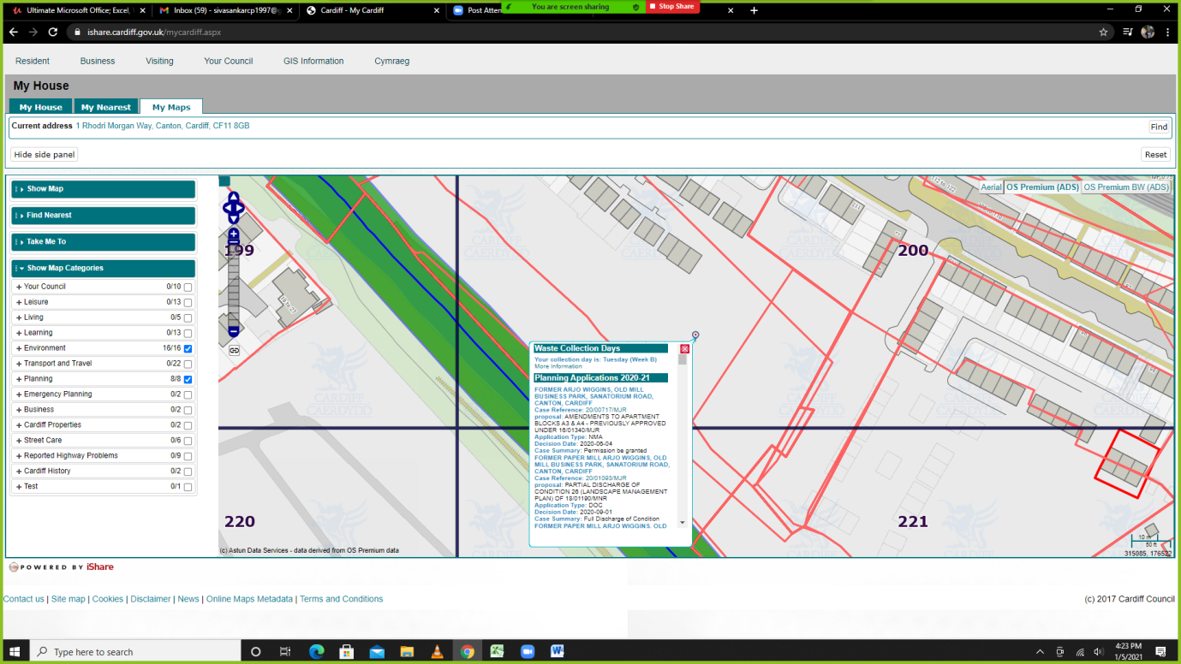

**Planning Applications 2020-21**

**FORMER ARJO WIGGINS, OLD MILL BUSINESS PARK, SANATORIUM ROAD, CANTON, CARDIFF**

**Case Reference:** [20/00717/MJR](https://planningonline.cardiff.gov.uk/online-applications/applicationDetails.do?activeTab=summary&keyVal=_CARDIFF_DCAPR_130703)

**proposal:** AMENDMENTS TO APARTMENT BLOCKS A3 & A4 - PREVIOUSLY APPROVED UNDER 16/01340/MJR

**Application Type:** NMA

**Decision Date:** 2020-06-04

**Case Summary:** Permission be granted

**FORMER PAPER MILL ARJO WIGGINS, OLD MILL BUSINESS PARK, SANATORIUM ROAD, CANTON, CARDIFF**

**Case Reference:** [20/01093/MJR](https://planningonline.cardiff.gov.uk/online-applications/applicationDetails.do?activeTab=summary&keyVal=_CARDIFF_DCAPR_131148)

**proposal:** PARTIAL DISCHARGE OF CONDITION 26 (LANDSCAPE MANAGEMENT PLAN) OF 18/01190/MNR

**Application Type:** DOC

**Decision Date:** 2020-09-01

**Case Summary:** Full Discharge of Condition

**FORMER PAPER MILL ARJO WIGGINS, OLD MILL BUSINESS PARK, SANATORIUM ROAD, CANTON, CARDIFF**

**Case Reference:** [20/01540/MJR](https://planningonline.cardiff.gov.uk/online-applications/applicationDetails.do?activeTab=summary&keyVal=_CARDIFF_DCAPR_131659)

**proposal:** PARTIAL DISCHARGE OF CONDITION 9 (WALKWAY/CYCLEWAY) OF 18/01190/MNR

**Application Type:** DOC

**Decision Date:** 2020-10-26

**Case Summary:** Partial Discharge of Condition (s)

**FORMER PAPER MILL ARJO WIGGINS, OLD MILL BUSINESS PARK, SANATORIUM ROAD, CANTON, CARDIFF**

**Case Reference:** [20/01847/MJR](https://planningonline.cardiff.gov.uk/online-applications/applicationDetails.do?activeTab=summary&keyVal=_CARDIFF_DCAPR_132023)

**proposal:** PARTIAL DISCHARGE OF CONDITION 6 (TOPSOIL) OF 18/01190/MNR

**Application Type:** DOC

**Case Summary:** Undecided

1. Extract the above fields and populate in Excel sheet. Above has 4 sets of data, this will vary, few will return more or less sets of data.